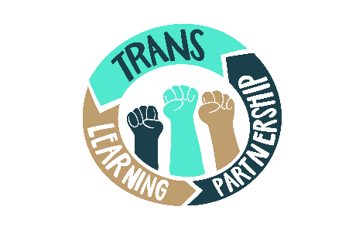
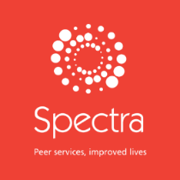

RESEARCH COORDINATOR

TRANS LEARNING PARTNERSHIP

JOB DESCRIPTION

Reports to: Chief Executive and Spectra Director

Spectra Location: Ladbroke Grove, London W10. Home working possible.

Salary: £36,000 to £40,000 according to experience, plus pension contribution

Job Share: The TLP is open to applicants who are interested in job sharing as well as those who are interested in the full time role. Please indicate this in your application personal statement.

We value the importance of representation and seek to diversify our workforce, and so actively encourage applications from eligible BPOC candidates.

Responsible for: Research project specific management of research assistants, enumerators and consultants.

All resources, software and equipment required for the role will be provided by Spectra.

Main purpose of role:

The Trans Learning Partnership (TLP) is a partnership between people from trans and non-binary communities, organisations that offer trans-peer delivered services, and academics. Placing the community at the centre of its model and utilising inclusive and participatory approaches, this partnership aims to make research and service monitoring data work effectively for those it is supposed to serve.

This post holder will work with the TLP partners, leading in the development of Research Grants to secure funding to research projects, which the research coordinator will lead. They will be instrumental in furthering the concept and plan for the TLP, enabling the next stage of the project. This will include formative participatory research agenda formation, overseeing development of the Monitoring, Verification & Evaluation (MVE) platform.

This post is ideal for a researcher interested in the field of gender identity with some expertise in successful grant writing who wishes to increase their knowledge and experience in this area, working closely with the trans community and senior academics in this field.

This role will involve:

Leading and coordinating research funding applications

- Formulate research questions into a cohesive agenda
- Keep up to date on relevant funding streams and identify funding opportunities in good time
- Identify protocols for writing for questions, conceptualise and draft applications.
- Coordinate and/or prepare required information e.g. supporting documents, related literature reviews, research frameworks, and policy briefs.

Liaising with partners

- Build functional communicative working relationships with the University of Nottingham, Goldsmiths College, University of London (academic partners); Gendered Intelligence, LGBT Foundation, and Mermaids (voluntary sector partners); and trans community representatives.
- Manage time and inputs of partners in line with the budget and project plan
- Ensure guidance and technical expertise of partners is implemented in research proposal and implementation activities while maintaining the TLP programme and vision at all levels
- Facilitate collaboration on drafting funding bids
- Ensure that a diverse range of trans people are involved in decision-making at all levels of the project

Formative Research
- Facilitate the development of the TLP’s research agenda and finesse research questions identified by trans community.

Operationalise both formative and funded research
- To organise and manage timelines for data collections and logistics. This may include training people, developing tools, ethical clearances, hiring experts, mobilising data collectors, implement methods, quality assure, participation in analysis
- To work in conjunction with others in the research team to achieve the research project objectives within the required timeline.
- Ensure that the research objectives comply with the relevant regulations and the specific operation procedures.

Write up and disseminate
- To lead and/or contribute to the production of academic papers, research reports and policy briefs, and prepare and present papers on research progress and outcomes to relevant groups (TLP and where relevant the Advisory Group) including external bodies.
- To share information and ideas with community participants and communicate with trans communities in accessible and inclusive ways, ensuring that the project is accountable and beneficial to trans communities.
- To build relationships with internal and external contacts to develop knowledge and understanding and form relationships for future collaborations.

Team co-ordination and management
- To support the development of the Monitoring, Verification and Evaluation (MVE) database/platform. This will include managing data officers and consultants, overseeing the MVE development plan, and project-specific co-ordination with research officers based in other organisations.
- Co-ordinate and administrate the TLP Steering Group and Advisory Group
- Monitor the programme budget
- As the TLP grows, take oversight of a broader staff team.

Person Specification:

Knowledge and Experience:
- Experience in use of qualitative and quantitative research methodologies and techniques to work within area.
- Some practical experience of applying the specialist skills and approaches and techniques required for the role: in particular participatory research frameworks.
- Previous experience of successful grant applications to, for example, National Institute for Health Research (NIHR); Economic & Social Research Council (ESRC); European Research Council grants; Leverhulme Trust, Wellcome Trust and other Trusts & Foundations.
- Research expertise in trans health
- Thorough understanding of research ethics

Qualifications & Skills
- Masters degree or equivalent in relevant area.
- Excellent oral and written communication skills, including the ability to communicate with clarity on complex information.
- Ability to manage/ coordinate a multi-faceted project plan.
- Evidence of sufficient breadth or depth of research methodologies and techniques to work in research area.
- Ability to contribute to method improvement.
- Analytical ability to facilitate conceptual thinking, innovation and creativity.
- Excellent interpersonal and communication skills necessary to develop and maintain effective working relationships with a wide range of colleagues, co-researchers, participants across the partnership
- Ability to work effectively within a team including with colleagues based at other institutions

Personal qualities
- Excellent time-management and organisational skills
- Ability to work to deadlines and prioritise tasks
- Understanding of issues and concerns relevant to the transgender community
- An understanding of intersectionality and multiple marginalisation, especially as it relates to trans communities
- A self-motivated team player
- Able to work independently
- Flexible and adaptable
- Entrepreneurial and innovative
- An eye for detail and ability to work carefully and methodically
- Solution focused ’can do’ attitude

Able unequivocally to respect, support, promote and work within LGBTQ+ and other diverse communities.

