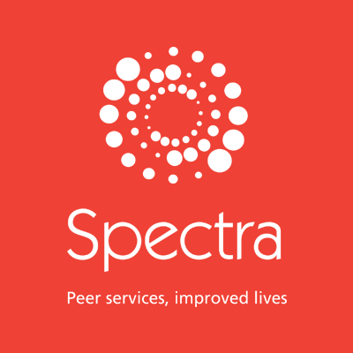

Trans/Non-Binary Peer Mentoring Programme
MENTOR Application Form

For office use
Client Code:
Date Received:
Assigned to:

Spectra’s trans peer mentoring programme is designed to provide 2 types of ONLINE, but normally in-person* support (*suspended due to COVID-19). The support is informal but structured and duration can either be long (8 modules) or short (4 modules). Sessions take place either weekly, fortnightly, or every month, as agreed between the mentor and mentee at the start of the programme. Spectra will process and be in control of the data provided on this form.
The information which you provide in this form and any other information obtained or provided during the course of your mentoring with us (“the information”) will be used for the purpose of assessing your suitability for the service, in emergency situations e.g. to protect life or in a medical situation, and in relation to legitimate interests of our business.
If your application is successful, the information will form part of your mentee file and we will be entitled to process it for all purposes in connection with your case. Once you complete or leave our service, the information will be retained for a further 7 years, after which time it will be destroyed.
You have the right to data portability, request access to, rectification or erasure of your data collected as part of this process.
So that we may use the information for the above purposes and on the above terms, we are required to obtain your explicit consent. Accordingly, please sign the consent section at the end of this form. You have the right to withdraw your consent at any time and the right to lodge a complaint with the Information Commissioner.

Thank you for your interest in being a Peer Mentor with Spectra. If you need any help filling out this form, please contact the Trans Services Team on trans@spectra-london.org.uk

MENTEE CONTACT INFORMATION
Name (First, Surname)
Preferred name
Email
Mobile Number
DEMOGRAPHICS These details will be used for internal monitoring purposes only, to help us assess whether we are reaching all groups. These details will not be used, except in anonymous format, outside Spectra.
Date of Birth:
Address:

Borough: |  |  | Postcode:
Ethnicity: Asian British Asian Indian Asian Pakistani Asian Other Chinese
Black British Black Caribbean Black African Black Other
White British White Irish White Other Mixed…………………..... Other…………………..
Sexual orientation: Gay Bisexual MSM Not sure Other:……………………

Gender Identity: | Male Female Non-Binary/ Trans*/gender minority identity  (Please state) ……………………………………………..  Preferred pronoun/s:
Do you consider yourself to have a disability or neurodiversity’s?
Yes (please state) : No
What is your employment status? (please state)

How did you find us? (Please provide detail. e.g. google, clinic Q)

Availability
Mentoring usually involves about an hours’ commitment each week, fortnight or monthly. Which of the following are you usually be available for?
 | Mon | Tue | Wed | Thur | Fri | Sat | Sun
AM
PM
Evening

What do you hope to gain from being a Mentor?

Please tell us a little bit more about yourself. Do you have hobbies and interests? Do you work or are you studying?

SIGN UP INFORMATION
Spectra will retain a record of your name and contact detail in order to be able to communicate with you in relation to mentoring service and/or case management.
Spectra does not share your personal data with third parties.
You are confirming that you are consenting to the Spectra holding and processing your personal data for the following purposes (please tick the boxes where you grant consent):
- I agree that Spectra may keep me informed about news, events, activities and services of Spectra (note you can unsubscribe from us at any time).
- I agree that Spectra may keep me informed about news, events, activities and services of Spectra’s partner organisations.
You may withdraw your consent for Spectra (data controller) to retain your personal data at any time by informing us tel: 08005878302 or email: dataprotectionofficer@spectra-london.org.uk

Signature: Date:

You can find out more about how we use your data from our “Privacy Policy” which is available from our website: www.spectra-london.org.uk.

ADDITIONAL TRANS PROGRAMME SERVICES

SOCIAL GROUPS
Social groups for trans, non-binary and questioning people offering a safe, trans-led space to meet, socialize, support, take part in activities, workshops and enjoy a variety of speakers. Each session includes social time, discussion and activities.
Please Tick
☐ I am interested in attending Spectra social groups.
☐ I am not interested in attending Spectra social groups.

COUNSELLING
The Counselling Service offers free, short-term one-to-one counselling and group counselling for people who identify as trans, non-binary or are questioning their gender identity. Counselling is a talking therapy and an opportunity to explore issues you are facing in your life in safe, confidential environment with a trained professional.
Please Tick
☐ I am interested in Counselling.
☐ I am Not interested in Counselling.

Please return this form by emailing it to
Trans@spectra-london.org.uk

